Pokhara University

Level: Bachelor | Semester – Spring | Year : 2005
Programme: BE |  | Full Marks: 100
Course: Integrated Digital Electronics |  | Time : 3hrs.

Candidates are required to give their answers in their own words as far as practicable.
The figures in the margin indicate full marks.

Attempt all the questions.

 | - Construct a layout for 2 bit IIL decoder.  - For the circuit shown below, assume β =50. V_{BE(ON)} = V_{BE(SAT)} = 0.7V, V_{CE(SAT)} = 0.2V.  - Calculate the Logic swing and Noise margins for fan out = 5.  - Compute fan out for NM_{H} = NM_{L.}  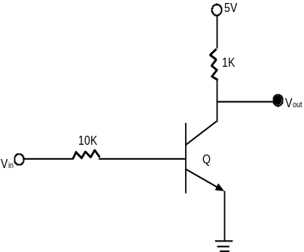 | 8  7
 | - Discuss the rise time, fall time and propagation delay for the typical DTL gate.  OR  Approximate the fan out of a typical DTL gate and explain the result obtained.  - Draw a schematic circuit diagram for the three inputs TTL NAND gate with active pull up and explain its operation in details. | 8  7
 | - What types of errors may occur in ECL interconnections? How can we eliminate such errors?  - In IC-TTL circuit shown in figure below, assume the VBE(sat) = 0.8V, VCE(sat) = 0.1V, VBE(on) = VD_{(on)} = 0.7V. Find the voltage at B1, C2, B3 and Y, when  - V_{A} = V_{B} = 5 Volts  - V_{A} = 5 Volts, V_{B} = 0.1 Volt.  - V_{A} = V_{B} = 0.1 Volt.  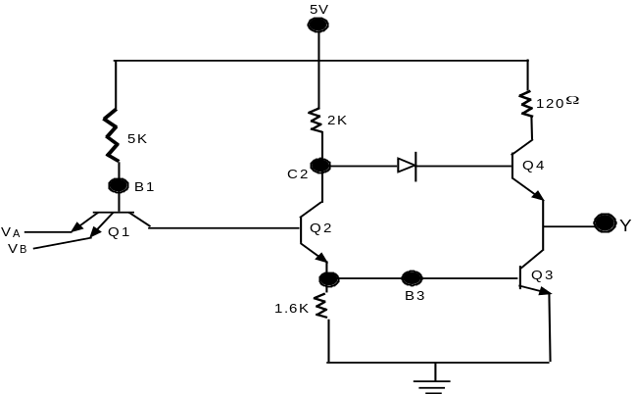 | 7  8
 | - For an NMOS inverter, find the critical points on voltage transfer characteristics.  - Explain the read, write and refresh operation in dynamic RAM with circuit diagram. | 8  7
 | - Draw the MOSRAM memory cell and explain the read and write operation.  - Discuss the various semiconductor memory types. | 8  7
 | - Explain the operation of CMOS gate with neat circuit diagram.  - List out the different features of VHDL that differentiate it from other hardware description languages.  - Model a 2 to 4 decoder circuits in VHDL. | 5  5  5
 | Write short notes on (Any Two):  - High Threshold Logic  - RTL XOR gate  - Charge Coupled Device (CCD)  - Diode Transmission gates | 2x5

